**Experiment 5:**

Harmonic Oscillator

Part I. Spring Oscillator

**Name:** Omar Ozgur

**Date:** November 2, 2015 (11/02/15)

**Lab:** Section 1, Monday 9am

**TA:** Hector Garcia

**Lab Partner(s):** Christie Matthews, Fiona Guo

**Introduction**

The purpose of this experiment was to study the movement of an object during damped and undamped harmonic oscillation. In order to perform the experiment, a spring was attached vertically to a force sensor, and a weight with magnets on the sides was attached to the bottom of the spring. By dropping the weight from above the equilibrium position, harmonic oscillation could be observed. Undamped oscillation was observed when the weight oscillated freely in air. In order to observe damped oscillation, the weight was dropped into an aluminum tube so that induced currents in the metal would provide a constant damping force.

In order to derive relationships for the analysis, it was important to analyze the forces that were acting on the oscillating weight by using equation 1.0 below. The damping force is included in these calculations, which is set to zero if no damping was applied. In these equations, “F” is the force moves the weight towards the equilibrium position, “k” is the spring constant, “x” is the position of the weight relative to its equilibrium position, “b” is the damping coefficient, and “v” is the velocity of the weight along the axis of oscillation.

$F=-kx-bv$ (Eq. 1.0)

$mx"+bx'+kx=0$ (Eq. 1.1)

The position “x(t)” of the weight at a given time “t” can be found by using equation 1.2 below, where “A” is the amplitude of the oscillatory movement, and “ $ω$” is the angular frequency. This equation provides a general form for the position of an object based on oscillatory motion.

$x\left(t\right)=Ae^{iωt}$ (Eq. 1.2)

By using equation 1.2 in conjunction with equation 1.1, the angular frequency “ $ω$” of the system can be derived.

$-ω^{2}mAe^{iωt}+iωb{Ae}^{iωt}+kAe^{iωt}=0$ (Eq. 1.3)

$ω=\frac{ib}{2m}±\sqrt{\frac{k}{m}-\frac{b^{2}}{4m^{2}}}$ (Eq. 1.4)

The frequency “f0” of the undamped system can be found by using “ $ω$” in equations 1.5 and 1.6 below. In the undamped case, it is assumed that the damping coefficient “b” is zero.

$f= \frac{ω}{2π}$ (Eq. 1.5)

$f_{0}=\frac{1}{2π}\sqrt{\frac{k}{m}}$ (Eq. 1.6)

In order to find the damping time “ $τ$”, equation 1.4 can be used in conjunction with equation 1.2 to produce equation 1.7 below. Since the second term in the resulting equation represents exponential decay, the damping time can be found to fit the form “ $e^{-\frac{t}{τ}}$”.

$x\left(t\right)=Ae^{i\left(\frac{ib}{2m}+\sqrt{\frac{k}{m}-\frac{b^{2}}{4m^{2}}}\right)t}=Ae^{i\left(\sqrt{\frac{k}{m}-\frac{b^{2}}{4m^{2}}}\right)t}{*e}^{\frac{-bt}{2m}}$ (Eq. 1.7)

$τ=\frac{2m}{b}$ (Eq. 1.8)

In order to make calculations easier for subsequent equations, the quality factor “Q” is defined as follows.

$Q=\frac{\sqrt{km}}{b}$ (Eq. 1.9)

Based on equations 1.8 and 1.9, the damping coefficient “b” can be found in two ways.

$b=\frac{2m}{τ}$ (Eq. 2.0)

$b=\frac{\sqrt{km}}{Q}$ (Eq. 2.1)

During damped oscillation, the nonzero damping coefficient causes the damped frequency “fdamped” to differ from the undamped frequency “f0”, as shown in equation 2.2 below.

$f_{damped}=\frac{1}{2π}\sqrt{\frac{k}{m}-\frac{b^{2}}{4m^{2}}}=f_{0}\sqrt{1-\frac{b^{2}}{4km}}=f_{0}\sqrt{1-\frac{1}{4Q^{2}}}$ (Eq. 2.2)

After performing the experiment and obtaining graphs of voltage readings over time, the successive maxima could be used to find measured values of frequency and damping time. The equation that can be used to calculate frequency “fmeasured” based on experimental data is given below, where “n” is the number of successive maxima.

$f_{measured}=\frac{n-1}{Δt}$ (Eq. 2.3)

The ratios of voltages of successive maxima can be used in order to obtain the decay time from experimental data, as shown in equations 2.4 and 2.5 below, where “T” is the time between the maxima.

$\frac{V(t+T)}{V(t)}=\frac{e^{-\frac{t+T}{τ}}}{e^{-\frac{t}{τ}}}=e^{-\frac{T}{τ}}$ (Eq. 2.4)

$τ=-\frac{T}{ln⁡(\frac{V(t+T)}{V(t)})}$ (Eq. 2.5)

**Experimental Results and Data Analysis**

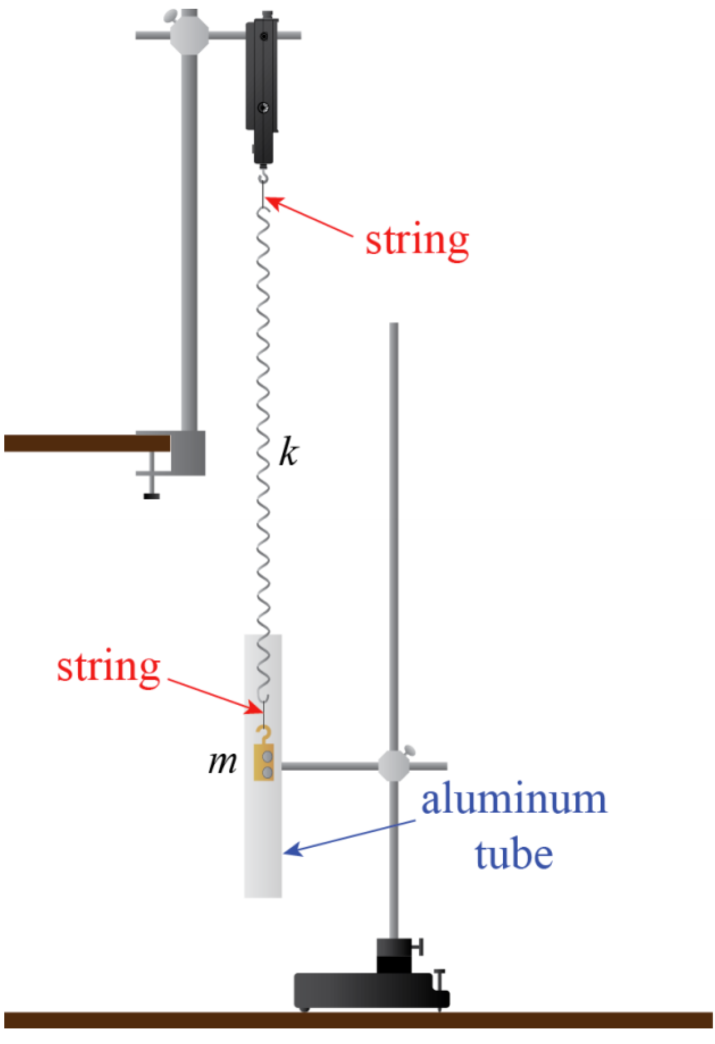

Figure : Experiment Setup: This diagram shows how the experiment was set up. Metallic rods were attached to the edge of a table in order to hold a force sensor far above the ground. One end of a spring was attached to the force sensor, while the other end was attached to a weight that contained magnets. Vertical displacement of the weight from equilibrium caused harmonic oscillation to occur. Damped oscillation was demonstrated by allowing the weight to oscillate within an aluminum tube, which caused induced currents to provide a damping force. (Source: UCLA Physics 4AL Lab Manual v. 20)

The mass of the hanging weight was found to be 174.20 ± 0.14g. The uncertainty in this measurement was found by using equation ii.22 from the lab manual.

$If f=x+z: δf=\sqrt{δx+δz}$ (Eq. ii.22)

$δm=\sqrt{{\left(δ_{scale}\right)}^{2}+{\left(δm_{balance}\right)}^{2}}$ (Eq. 2.6)

In order to determine the spring constant of the spring that was used during the experiment, 5 different weights were hung from the spring, and the distance from the bottom of each weight to the floor was recorded. This data was used to find a relationship between the tension that was applied to the spring, and the distance to the floor, which was used to determine the spring constant.

Figure : Spring Constant Calculation: In order to determine the spring constant, 5 different weights were hung from the spring, and their distances to the floor were recorded. The data was plotted on this graph, which shows a linear trend line that relates tension to the measured distance. An equation for the line was found by doing regression analysis in Microsoft Excel, which was done by clicking “Data Analysis” under the “Data” tab. The equation corresponding to the trend line is T = (-3.27 ± 0.02 $\frac{N}{m}$) m + (2.75 ± 0.01 N). Based on this equation, the spring constant “k” is 3.27 ± 0.02 $\frac{N}{m}$.

After analyzing the data in figure 2 by using the regression tool in Microsoft Excel, the spring constant “k” was found to be 3.27 ± 0.02 N/m.

In order to calculate the predicted free oscillation frequency, equation 2.7 was used. The uncertainty was calculated by using equations ii.21, ii.23 and ii.24 in the lab manual.

$f_{0_{best}}=\frac{1}{2π}\sqrt{\frac{k_{best}}{m_{best}}}$ (Eq. 2.7)

$If f=Ax: δf=|A|δx$ (Eq. ii.21)

$If f=\frac{x}{z}: \frac{δf}{|f_{best}|}=\sqrt{{\left(\frac{δx}{|x_{best}|}\right)}^{2}+…+{\left(\frac{δz}{|z_{best}|}\right)}^{2}}$ (Eq. ii.23)

$If f=Ax^{n}: \frac{δf}{|f_{best}|}=|n|\frac{δx}{|x|}$ (Eq. ii.24)

$δf_{0}=\left|\frac{1}{2π}\right|\left|f_{0_{best}}\right|\left|\frac{1}{2}\right|\frac{\left|\frac{k_{best}}{m_{best}}\right|\sqrt{{\left(\frac{δk}{\left|k_{best}\right|}\right)}^{2}+{\left(\frac{δm}{\left|m_{best}\right|}\right)}^{2}}}{\left|\frac{k_{best}}{m_{best}}\right|}=\left|\frac{f_{0_{best}}}{4π}\right|\sqrt{{\left(\frac{δk}{|k_{best}|}\right)}^{2}+{\left(\frac{δm}{|m_{best}|}\right)}^{2}}$ (Eq. 2.8)

By using equations 2.7 and 2.8, the predicted free oscillation frequency was found to be 0.6896 ± 0.0003 s-1. In order to find the frequency based on experimental results, the voltage readings from the force sensor were plotted on a graph, as shown in figure 3.

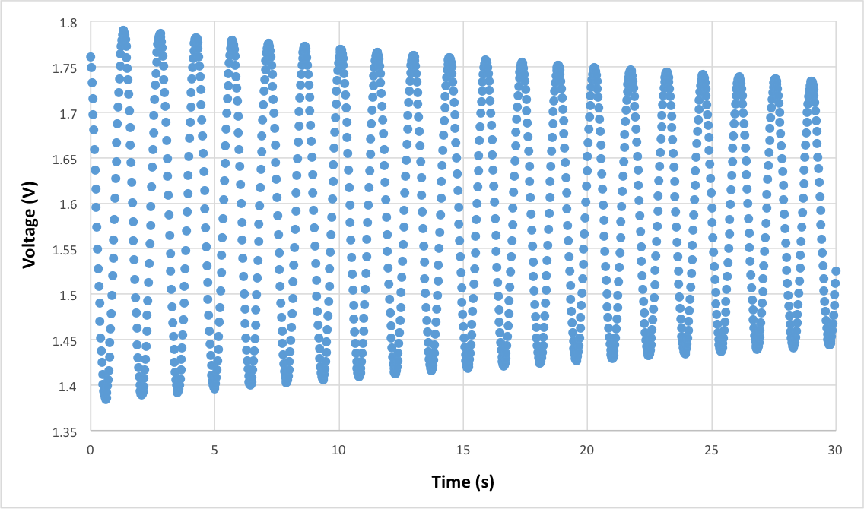

Figure : Free Oscillatory Motion: During the experiment, voltage readings from the force sensor were recorded at regular time intervals by a data acquisition system, and the data was used to create this graph. The oscillating voltage readings are due to changing tension by the weight on the force sensor. Although the oscillatory motion was undamped, a small amount of amplitude decay is shown due to external forces, such as air friction.

In order to determine the free oscillation frequency based on data gathered during the experiment, equation 2.9 was used, which relates the number of oscillation periods to the time that those periods spanned. In this equation, “n” is the number of successive maxima that were used from the data, and $∆t$ is the difference in time between the occurrence of the first and last maxima.

$f_{best}=\frac{n-1}{∆t}$ (Eq. 2.9)

In order to calculate the uncertainty of the calculated value, equation ii.13 from the lab manual was used, which is reformatted below. In order to use the equation, an average frequency value “fi” was calculated for every two successive maxima.

$δf= \frac{σf}{\sqrt{n}}=\frac{1}{\sqrt{n}}\sqrt{\frac{1}{n-1}\sum_{i=1}^{n}{{\left(f_{i}-f_{best}\right)}^{2}}}$ (Eq. 3.0)

By using equations 2.9 and 3.0, the measured frequency with uncertainty was found to be 0.686 ± 0.002 s-1. When compared to the predicted value of 0.6896 ± 0.0003 s-1, it can be seen do not agree with each other based on the calculated frequency ranges. This may be attributed to external forces that caused energy to be lost during the oscillations, which is evident due to the decreasing amplitudes of successive maxima in figure 3. If external forces were present, a non-zero damping coefficient would have caused a lower frequency to be measured, which held true in the calculated values.

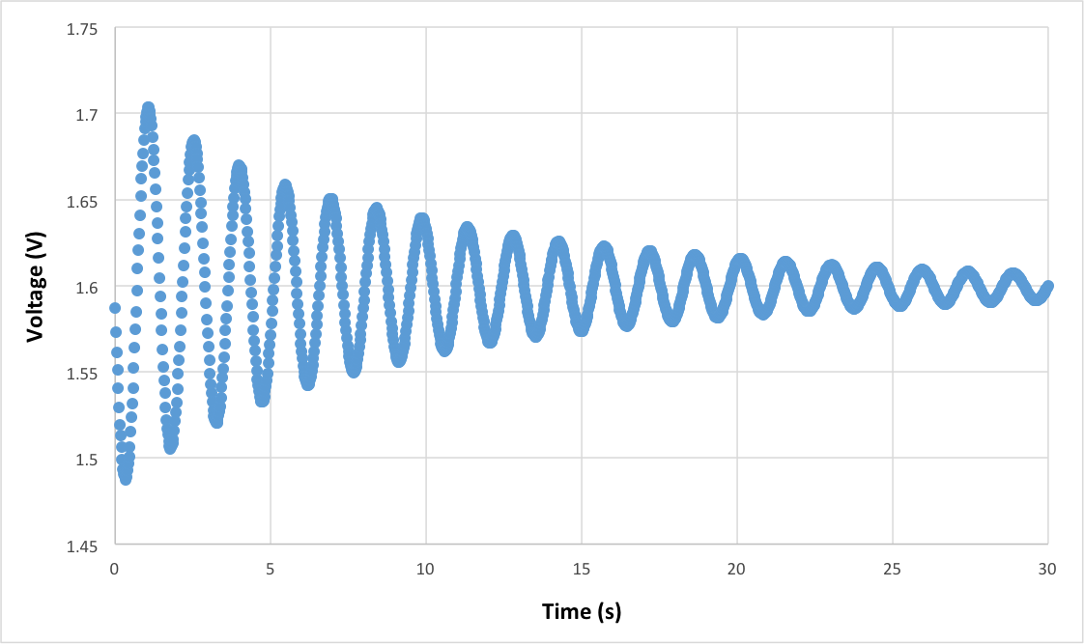

Figure : Damped Oscillatory Motion: During the experiment, voltage readings from the force sensor were recorded at regular time intervals by a data acquisition system, and the data was used to create this graph. The oscillating voltage readings are due to changing tension by the weight on the force sensor. Since a damping force was present, a large amount of amplitude decay is shown.

As seen in figure 4, the data that was gathered during damped oscillation was plotted on a graph in order to visually display the effects of damping on oscillatory motion. In order to calculate the measured frequency during the experiment, as well as the uncertainty in the value, equations 2.9 and 3.0 were used again. When determining the uncertainty, it was necessary to calculate the average frequency “fi” for each pair of maxima. Based on the 20 successive maxima that were used, the damped frequency “fdamped” was found to be 0.685 ± 0.004 s-1.

In order to determine if the damped oscillations were based on a velocity-dependent force, the mean voltage reading based on multiple oscillation periods was subtracted from the data, and the ratios between amplitudes of successive maxima were plotted in figure 5. These ratios could then be used to calculate the damping time.

Figure : Ratios of Successive Maxima: This graph gives a visual representation of the ratios between the amplitudes of successive maxima. There are not any major trends, and the ratios tended to stay between 0.8 and 0.9, showing that the damping was proportionate to velocity.

As shown in figure 5, the ratios between amplitudes of successive maxima mostly stayed within a small range, showing that damping was proportionate to velocity. By using equations 2.4 and 2.5, an average damping time “ $τ_{i}$” could be calculated for each pair of maxima. The average of these damping times would give the average damping time “ $τ$” for the system. The uncertainty could be found by using the best calculated damping time values in equation 3.1 below, which is based on equation ii.13 in the lab manual. Based on these equations, the average damping time was found to be 10.7 ± 0.7 s.

$\frac{V(t+T)}{V(t)}=\frac{e^{-\frac{t+T}{τ}}}{e^{-\frac{t}{τ}}}=e^{-\frac{T}{τ}}$ (Eq. 2.4)

$τ=-\frac{T}{ln⁡(\frac{V(t+T)}{V(t)})}$ (Eq. 2.5)

$δτ= \frac{στ}{\sqrt{n}}=\frac{1}{\sqrt{n}}\sqrt{\frac{1}{n-1}\sum_{i=1}^{n}{{\left(τ_{i}-τ_{best}\right)}^{2}}}$ (Eq. 3.1)

In order to calculate the quality factor “Q”, it is useful to first calculate the damping coefficient “b” by using equation 2.0. This value could then be used in equation 1.9 to calculate “Q”. The uncertainty was calculated by using equations 3.2 and 3.3 below, which are based on equations ii.21, ii.23, and ii.24 from the lab manual.

$b=\frac{2m}{τ}$ (Eq. 2.0)

$δb=|2||b_{best}|\sqrt{{\left(\frac{δm}{{|m}_{best}|}\right)}^{2}+{\left(\frac{δτ}{{|τ}_{best}|}\right)}^{2}}$ (Eq. 3.2)

$Q=\frac{\sqrt{km}}{b}$ (Eq. 1.9)

$δQ=\left|Q_{best}\right|\sqrt{{\left(\frac{δ\sqrt{km}}{\left|\sqrt{k_{best}m_{best}}\right|}\right)}^{2}+{\left(\frac{δb}{{|b}_{best}|}\right)}^{2}}=\left|Q_{best}\right|\sqrt{{\left(\frac{\left|\sqrt{k_{best}m_{best}}\right|\left|\frac{1}{2}\right|\left(\frac{δkm}{k_{best}m_{best}}\right)}{\left|\sqrt{k_{best}m_{best}}\right|}\right)}^{2}+{\left(\frac{δb}{{|b}_{best}|}\right)}^{2}}$

$δQ= \left|Q_{best}\right|\sqrt{{\left(\frac{1}{2}\left(\frac{\sqrt{δk^{2}+δm^{2}}}{k_{best}m_{best}}\right)\right)}^{2}+{\left(\frac{δb}{{|b}_{best}|}\right)}^{2}}$ (Eq. 3.3)

Based on these equations, the damping coefficient “b” was found to be 0.032 ± 0.004, and therefore, the quality factor “Q” was found to be 23.3 ± 2.9. By using this value, as well as the undamped frequency measurement “f0” based on equation 2.2, a predicted value for the damped oscillation frequency “fdamped” could be calculated. The uncertainty could be calculated with equation 3.4 below, which is based on equations ii.21, ii.22, ii.23, and ii.24 from the lab manual. These equations were used to predict that fdamped = 0.69 ± 0.17 s-1. The uncertainty in is relatively high due to uncertainty from the undamped frequency “ $f_{0}$” and the quality factor “Q”.

$f_{damped}=\frac{1}{2π}\sqrt{\frac{k}{m}-\frac{b^{2}}{4m^{2}}}=f_{0}\sqrt{1-\frac{b^{2}}{4km}}=f_{0}\sqrt{1-\frac{1}{4Q^{2}}}$ (Eq. 2.2)

$$δf_{damped}=\left|f_{damped_{best}}\right|\sqrt{{\left(\frac{δf_{0}}{\left|{f_{0}}_{best}\right|}\right)}^{2}+{\left(\frac{δ\sqrt{1-\frac{1}{4Q^{2}}}}{\left|\sqrt{1-\frac{1}{4Q_{best}^{2}}}\right|}\right)}^{2}}=\left|f_{damped_{best}}\right|\sqrt{{\left(\frac{δf_{0}}{\left|{f_{0}}_{best}\right|}\right)}^{2}+{\left(\frac{\left|\sqrt{1-\frac{1}{4Q_{best}^{2}}}\right|\left|\frac{1}{2}\right|\frac{δ\left(1-\frac{1}{4Q^{2}}\right)}{\left(1-\frac{1}{4Q_{best}^{2}}\right)}}{\left|\sqrt{1-\frac{1}{4Q_{best}^{2}}}\right|}\right)}^{2}}= \left|f_{damped_{best}}\right|\sqrt{{\left(\frac{δf_{0}}{\left|{f_{0}}_{best}\right|}\right)}^{2}+{\left(\left|\frac{1}{2}\right|\frac{\left|\left(1-\frac{1}{4Q_{best}^{2}}\right)\right|\sqrt{\frac{δ4Q^{2}}{\left|4Q_{best}^{2}\right|}}}{\left(1-\frac{1}{4Q_{best}^{2}}\right)}\right)}^{2}}=|f_{damped_{best}}|\sqrt{{\left(\frac{δf_{0}}{|{f_{0}}_{best}|}\right)}^{2}+{\left(\left|\frac{1}{2}\right|\sqrt{\frac{|4Q_{best}^{2}||2|\frac{δQ}{{|Q}_{best}|}}{|4Q_{best}^{2}|}}\right)}^{2}}$$

$δf_{damped}=|f_{damped_{best}}|\sqrt{{\left(\frac{δf_{0}}{|{f_{0}}_{best}|}\right)}^{2}+{\left(\frac{1}{2}\sqrt{\frac{2δQ}{|Q_{best}|}}\right)}^{2}}$ (Eq. 3.4)

The predicted frequency 0.69 ± 0.17 s-1 for damped oscillations agrees with the measured frequency 0.685 ± 0.004 s-1 based on the uncertainty ranges, which shows that the two frequencies are not distinguishable from each other.

**Conclusion**

The purpose of this experiment was to analyze the motion of an object during damped and undamped harmonic oscillation. In the undamped case, the predicted and measured values of oscillation frequency “f0” did not agree with each other. This may have been due to the presence of external forces that introduced an unwanted damping coefficient into the system, as evidenced by the data in figure 3. In the damped case, the predicted and measured values of oscillation frequency fit within each other’s uncertainty ranges, showing that the predicted results could be tested and verified through experiments.

One source of systematic uncertainty was due to external forces on the system, such as air resistance. This effect was especially noticeable in the undamped case based on the decreasing amplitudes of the maxima in figure 3. Since air resistance provides a velocity-dependent damping force in the form of fluid friction, the increased damping coefficient would cause a lower frequency to be measured. In order to record accurate results, it is necessary to make the air resistance as minimal as possible. One way to do this would be to perform the test in a vacuum so that no fluid friction would be present.

Another source of systematic uncertainty was due to errors in measurement while determining the spring constant. Since it was difficult to keep the ruler perfectly straight, as well as to keep the weight from moving, the distances that we measured from the ground to the weight may not have been accurate. This would have affected calculation of the spring constant. If the measurements caused the calculated spring constant to be higher than the true value, the calculated frequencies based on the ratio of the spring constant to the damping coefficient would have been larger. If the measurements caused the calculated spring constant to be lower than the true value, the calculated frequencies would have been lower. One way to eliminate this effect would be to hang the weight vertically against a wall, so that the ruler could be set flat against the wall while measuring the distance to the floor.

**Extra Credit**



Figure : Frequency-domain Representation: By using the Fast Fourier Transform (FFT) tool in the Capstone software, it was possible to generate this frequency-domain representation of the undamped oscillation data from the experiment. The width of the bars at a height of $1/\sqrt{2}$ of the maximum value can be used to calculate to width of resonance “ $∆f$”. This value can then be used to calculate the quality factor “Q”.

One way to calculate the quality factor “Q” was to use the Fast Fourier Transform (FFT) tool in Capstone to generate a frequency-domain representation of the data based on undamped oscillatory motion. The resulting graph can be seen in figure 6. By using this data, it is possible to find “Q” using equations 3.5, where “f0” is the resonant frequency, and “ $∆f$” is the width of resonance. The uncertainty could be calculated by using equation 3.6, which is based on equation ii.23 in the lab manual.

$Q=\frac{f_{0}}{∆f}$ (Eq. 3.5)

$δQ=|Q_{best}|\sqrt{{\left(\frac{δf_{0}}{|{f_{0}}_{best}|}\right)}^{2}+{\left(\frac{δ∆f}{|∆f_{best}|}\right)}^{2}}$ (Eq. 3.6)

Equation 3.7 can be used to calculate the width of resonance “ $∆f$”.

$∆f=width of peak at height \frac{1}{\sqrt{2}}V_{max}$ (Eq. 3.7)

In order to calculate “ $∆f$”, a ruler was first used to find $\frac{1}{\sqrt{2}}v_{max}$. Since 67 ± 1mm corresponds to 1 V on the graph, each millimeter represents 0.0149 ± 0.0002 V. Based on the maximum voltage of 1 V, $\frac{1}{\sqrt{2}}v_{max}$ is equal to $\frac{1}{\sqrt{2}} V$, which corresponds to a height of approximately 47 mm. This shows that “ $∆f$” is the change in frequency across two bars on the graph.

To finish calculating “ $∆f$”, a ruler was used to find that 112 ± 1mm corresponds to 1 Hz on the graph. This shows that each millimeter represents about 0.00893 ± 0.00008 Hz on the graph. Since each bar width is 4 ± 1mm, $∆f$ = 0.071 ± 0.02 Hz. The uncertainty values were obtained by using equation ii.23 in the lab manual, which deals with the propagation of uncertainty in products and ratios.

Since “f0” is located a distance of 79 ± 1mm from the origin, f0 = 0.705 ± 0.01 Hz. By using equation 3.5, the quality factor “Q” was found to be 9.9 ± 2.8. Compared to the value

23.3 ± 2.9 obtained from the time-domain analysis the values do not agree with each other. This may be due to the limited accuracy of the bars of the FFT graph. If the number of bars was raised to produce a smoother curve in figure 6, the calculated values of “Q” would likely have been much closer.